Proposal to expand Macquarie Island Marine Park

**Public consultation paper March 2023**

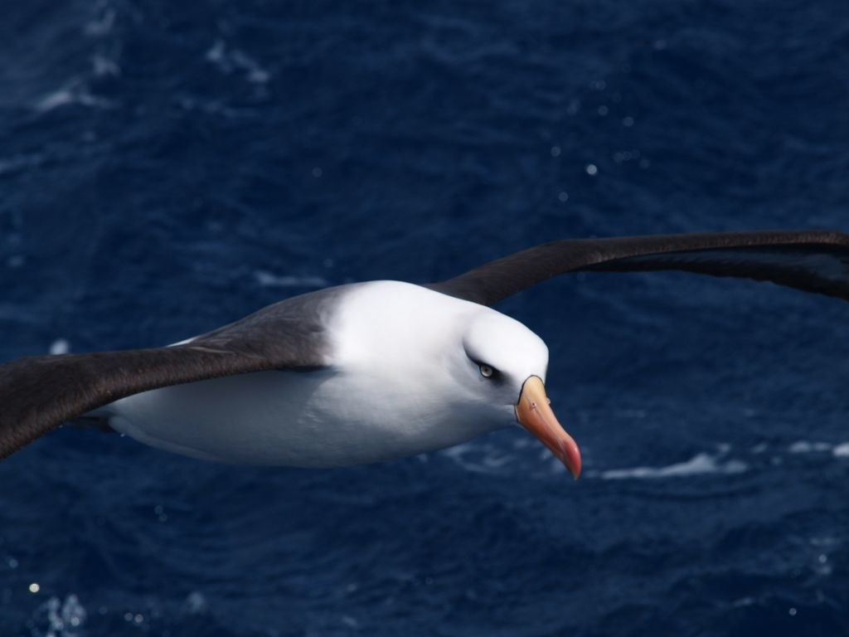

© Parks Australia (Commonwealth of Australia) 2023

**Ownership of intellectual property rights**

Unless otherwise noted, copyright (and any other intellectual property rights) in this publication is owned by Parks Australia (Commonwealth of Australia).

**Creative Commons licence**

All material in this publication is licensed under a Creative Commons Attribution 4.0 International Licence except content supplied by third parties, logos and the Commonwealth Coat of Arms.

This publication (and any material sourced from it) should be attributed as: AMP 2023, Proposal to expand Macquarie Island Marine Park – Public consultation paper, Australian Marine Parks, Canberra, March. CC BY 4.0.

This publication is available at parksaustralia.gov.au/marine

**Acknowledgement of Country**

Our department recognises the First Peoples of this nation and their ongoing connection to culture and country. We acknowledge First Nations Peoples as the Traditional Owners, Custodians and Lore Keepers of the world’s oldest living culture and pay respects to their Elders past, present and emerging.

Cover image: Campbell Albatross in flight (James Doube)

Contents

Purpose of this document 5

Have your say 7

Preface 8

1. Overview of Australian Marine Parks 10

2. Management of Macquarie Island and surrounding waters 11

3. The process required to expand Macquarie Island Marine Park 15

4. Rationale to expand Macquarie Island Marine Park 15

5. Natural Values 17

Geology and oceanography 17

Benthic habitat and communities 19

Pelagic habitat and fauna 20

Seabirds 20

Marine mammals 21

Fish 22

World Heritage Area (Macquarie Island and coastal habitat) 22

6. Integrating social, cultural and economic values in park planning 23

Background 23

Activities 23

Macquarie Island Toothfish Fishery 24

7. Pressures 25

Changing climate 25

Human activity 25

Shipping and vessel transit 25

Research and Monitoring 25

Commercial fishing 25

5. Proposed Macquarie Island Marine Park design 26

Macquarie Island Marine Park design 26

Zoning for the proposed expanded Macquarie Island Marine Park 28

(a) Sanctuary zone (IUCN category Ia) 28

(b) National Park Zone (IUCN category II) 28

(c) Habitat Protection Zone (Macquarie) (IUCN category IV) 28

Rationale for the park design and zoning 28

(a) Sanctuary zone (IUCN category Ia) 29

(b) National Park Zone 29

(c) Habitat Protection Zone 29

8. Acronyms 33

9. References and further reading 34

Appendix A Seabirds recorded within proposed marine park that are listed as threatened, marine or migratory under the EPBC Act 38

Appendix B Marine mammal species recorded within proposed marine park that are listed as threatened, marine, migratory or cetacean under the EPBC Act 40

Appendix C Geoscience Australia maritime boundary definitions 42

Figures

**Figure 1-Macquarie Island and Australia's Exclusive Economic Zone (EEZ)** 6

**Figure 2-Existing Australian Marine Parks and proposed Macquarie Island Marine Park** 9

**Figure 3 - Current design for Macquarie Island Marine Park** 10

**Figure 4- Proposed Macquarie Island Marine Park design** 11

**Figure 5-Proposed management arrangements for Macquarie Island and the surrounding waters** 12

**Figure 6- Map of the proposed Macquarie Island Marine Park displaying the currents, fronts and geomorphic features** 16

**Figure 7- Proposed design for the expanded Macquarie Island Marine Park, with co-ordinates** 23

Tables

**Table 1-Consultation on Macquarie Island Marine Park proclamation proposal** 4

**Table 2- Overview of current management arrangements in the waters surrounding Macquarie Island** 11

**Table 3- Overview of proposed activity prescriptions for Macquarie Island Marine Park** 27

**Table 4- Overview of proposed commercial fishing activity prescriptions for Macquarie Island Marine Park** 28

**Table 5- Summary of key information for the proposed Macquarie Island Marine Park** 29

# Purpose of this document

The *Proposal to expand Macquarie Island Marine Park — Public consultation paper* (‘proclamation proposal’)has been prepared to support public consultation on the proposed design of an expanded Macquarie Island Marine Park. This document provides context to assist the public to provide written comments on the proposed expansion for at least sixty days, as required under the *Environment Protection and Biodiversity Conservation Act 1999* (EPBC Act).

This document describes:

* the reasons, legal basis and processes for proclaiming Australian Marine Parks
* the context, approach and information used to design the proposal
* the natural, cultural, social and economic values and uses of the marine park
* the purpose, description and design (area, location, zoning and maps) of the proposed expansion of Macquarie Island Marine Park.

The preparation of this proposal involved the collation and synthesis of information on the natural, social, and economic values and uses of the Macquarie Island Marine Park and the surrounding area.

Table 1 describes the consultation process and steps to establish the expanded marine park.

**Table 1-Consultation on Macquarie Island Marine Park proclamation proposal**

|  |  |
| --- | --- |
| **Step** | **Timing** |
| 1. Targeted stakeholder engagement to gather information to prepare a draft proposal for the expansion of Macquarie Island Marine Park (completed) | October – February 2023 |
| 2. Release of the gazette notice and proclamation proposal (this document) for public comment for at least 60 days. | **Current step** |
| 3. The Director of National Parks prepares a report (which includes consideration of any public comments) for the Minister for the Environment on the proclamation of an expanded marine park. | Follows step 2 |
| 4. The Minister must consider the report and make a final decision. | Follows step 3 |
| 5. Proclamation is made by the Governor- General to expand the Macquarie Island Marine Park. | Follows step 4 |

Management arrangements for the expanded Macquarie Island Marine Park would be established under the South-east Marine Parks Network Management Plan. Public consultation on the new management plan will occur following the proclamation of Macquarie Island Marine Park.

# Have your say

We welcome your comments on the proclamation proposal.

*Submissions should be submitted to the Department of Climate Change, Energy, the Environment and Water’s Have Your Say website at* <https://consult.dcceew.gov.au/>

Submissions must be received by 11:59pm AEDT 22 May 2023. Submissions received before the commencement date or after the closing date will not be considered.

Comments will be included and considered in a report to be prepared by the Director of National Parks (the Director) for the Minister for the Environment under subsection 351(1) of the EPBC Act. Comments sent after 22 May 2023 will not be considered or included in the Director’s report. The Director’s report will be published on the Director of National Parks’ website (parksaustralia.gov.au).

All comments and information received will be treated as public documents and may be published in full on the Director of National Parks’ website and/or the Department of Climate Change, Energy, the Environment, and Water’s website.

All comments will be managed in accordance with the Director of National Parks’ privacy policy which is available at <https://www.dcceew.gov.au/parks-heritage/national-parks/parks-australia/privacy-policy>.

Further information on the South-east Marine Parks Network (including Macquarie Island Marine Park) is available via the website [www.parksaustralia.gov.au/marine](http://www.parksaustralia.gov.au/marine), or via email to [MIMPexpansion@dcceew.gov.au](mailto:MIMPexpansion@dcceew.gov.au).

# Preface

Australia’s South-east Marine Parks Network is home to unique features that have supported diverse marine life over thousands of years. With a variety of seafloor features and historically stable marine climate, the South-east Marine Parks Network hosts globally significant biological communities.

This is particularly true for Macquarie Island, whose remoteness and rare geomorphological formations have resulted in valuable and globally significant marine and terrestrial features, habitats and species. The Macquarie Island Marine Park features distinctive sub-Antarctic organisms and protects tracts of the wild Southern Ocean to provide migration, feeding and breeding sites for seals, whales, penguins and seabirds**.**

**Figure 1-Macquarie Island and Australia's Exclusive Economic Zone (EEZ)**

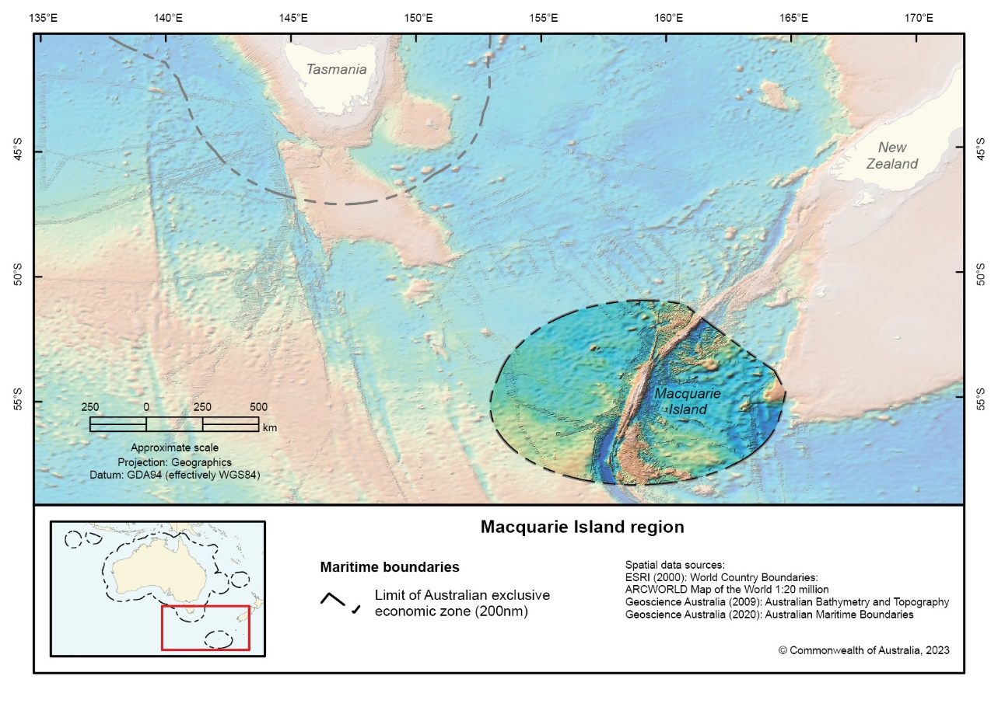

Australian Marine Parks are created and managed to achieve the dual objectives of protecting and conserving biodiversity, while supporting compatible ecologically sustainable use. The proposed expansion of Macquarie Island Marine Park would afford greater protection to the Macquarie Island World Heritage Area, would protect the entirety of the wild and pristine Macquarie Province Bioregion within Australia’s Exclusive Economic Zone and its associated seafloor features and increase the level of protection for important areas for threatened and migratory species. It would also enable the continuation of a well-regulated and highly sustainable toothfish fishery within its existing footprint.

The sub-Antarctic regions of the Southern Ocean play a critical role in stabilising global climate and circulating nutrients that sustain marine life around the world. Our oceans are subject to a range of pressures and are changing at a rate faster than many species can adapt to.

An expanded Macquarie Island Marine Park would help mitigate human and environmental pressures by protecting globally significant biological and biogeographical values. By creating spaces where marine species can thrive with no or minimum disturbance, marine parks not only conserve biodiversity but also help to support the needs and aspirations of future generations.

# Overview of Australian Marine Parks

In 1998, Commonwealth, State and Territory governments agreed to work towards the National Representative System of Marine Protected Areas (NRSMPA). The primary goal of the NRSMPA is to establish and manage a comprehensive, adequate and representative system of marine protected areas. Broadly, this means ensuring the system of marine parks includes all of Australia’s marine bioregions, and that the range of different ecosystems and biological features within these bioregions are adequately represented in marine parks to ensure their long-term viability.

The Australian Government’s contribution to the NRSMPA includes 60 Australian Marine Parks (AMPs, managed by the Director of National Parks), the Great Barrier Reef Marine Park (managed by the Great Barrier Reef Marine Park Authority), and the Heard Island and McDonald Islands Marine Reserve (managed by the Australian Antarctic Division). Altogether, these parks cover an area of around 4 million km2 in Commonwealth waters (Figure 2). Around mainland Australia, the Commonwealth marine area extends generally from 3 nautical miles from Australia’s shoreline to the edge of Australia’s EEZ (approximately 200 nautical miles), with the area inside 3 nautical miles managed by the States and Territories.

The combined Commonwealth, State and Territory marine park estate protects 45% of Australia’s waters. The proposed expansion of the Macquarie Island Marine Park would see protection of Australia’s marine estate rise to 48%.

AMPs are established and proclaimed in accordance with the requirements of the EPBC Act. These requirements include:

* the need for at least 60 days of public consultation on the proposed AMPs;
* preparing a report to the Minister for the Environment on the proposed AMP proclamation and the comments received from public consultation;
* assigning to each AMP, or to each zone within an AMP, an International Union for the Conservation of Nature (IUCN) protected area category or categories. The six IUCN categories are defined under the *Environmental Protection and Biodiversity Conservation Regulations 2000* and differ in the level and type of protection they afford, ranging from ‘multiple use’ to ‘sanctuary’.

Once a marine park is declared, the EPBC Act requires the Director of National Parks (DNP) to administer, manage and control AMPs, including preparing management plans as soon as practicable after they are proclaimed. These management plans describe how AMPs, and their values will be protected, conserved, and managed. For example, they describe what activities can and can’t occur in AMPs, as well as research, monitoring and management priorities.

**Figure 2-Existing Australian Marine Parks, including the proposed Macquarie Island Marine Park**

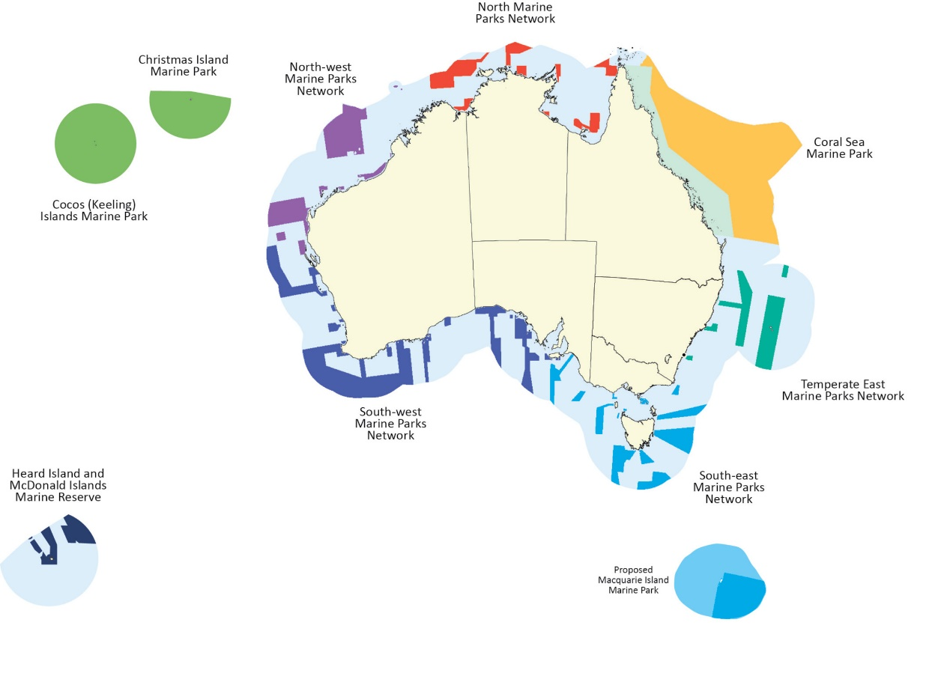

Heard Island and McDonald Islands Marine Reserve is a Commonwealth reserve managed by the Australian Antarctic Division.

# Management of Macquarie Island and surrounding waters

Macquarie Island is a Tasmanian island, situated in the Southern Ocean, 1500 km south-east of Tasmania and approximately halfway between Australia and the Antarctic continent. The island is 34 km long and up to 5 km wide, with two small groups of islands, Judge and Clerk Islets and Bishop and Clerk Islets. The island was made a wildlife sanctuary in 1933 under the *Animals and Birds Protection Act 1928* (Tasmanian Government Gazette, 23 May 1933), and was reproclaimed in 1972 as the Macquarie Island Wildlife Reserve. In 1978, it was renamed the Macquarie Island Nature Reserve.

The Tasmanian Government’s Macquarie Island Nature Reserve comprises 875 km2 and includes the coastal waters within 3 nautical miles of the island. In 1997, the reserve and its surrounding territorial waters to 12 nautical miles were inscribed on the World Heritage List as the Macquarie Island World Heritage Area. The World Heritage Area is managed by the Commonwealth and Tasmanian Governments under an agreement to facilitate cooperative and complementary management arrangements of the waters in the World Heritage Area. Macquarie Island Nature Reserve, the World Heritage Area and surrounding waters out to 3 nautical miles are managed by Tasmania Parks and Wildlife Service under the *Macquarie Island Nature Reserve and World Heritage Area Management Plan 2006*.

The offshore Commonwealth waters of the current Macquarie Island Marine Park are managed by Parks Australia and cover 162,000 km2 (Figure 3). The existing Macquarie Island Marine Park is one of the 14 marine parks of the South-east Marine Parks Network. Management is governed by the *South-east Marine Parks Network Management Plan 2013-2023 (Director of National Parks 2013).*

**Figure 3 - Current design for Macquarie Island Marine Park**

**Map of the Macquarie Island region and Australia's Exclusive Economic Zone, with the current Macquarie Island Marine Park zoning.

The current zoning includes categories IUCN Ia and IUCN IV.**

**Table 2- Overview of current management arrangements in the waters surrounding Macquarie Island**

|  |  |  |
| --- | --- | --- |
| **Distance (nautical mile)** | **Classification** | **Managing Authority** |
| < 3 nautical miles | Coastal Waters, World Heritage Area | Tasmanian Government (under 2006 Management Plan) |
| 3 – 12 nautical miles | Territorial Sea, World Heritage Area | Australian Government |
| 12 – 200 nautical miles | Exclusive Economic Zone (part of), Marine Park | Australian Government, with marine park managed by Parks Australia |

**Figure 4- Proposed Macquarie Island Marine Park design**

**Map of the Macquarie Island region and Australia's Exclusive Economic Zone, with the proposed Macquarie Island Marine Park zoning.

The proposed zoning includes categories IUCN Ia, IUCN II and IUCN IV. **

Refer to Section 5, Proposed Macquarie Island Marine Park design, for detailed description of the design.

**Figure 5-Proposed management arrangements for Macquarie Island and the surrounding waters**

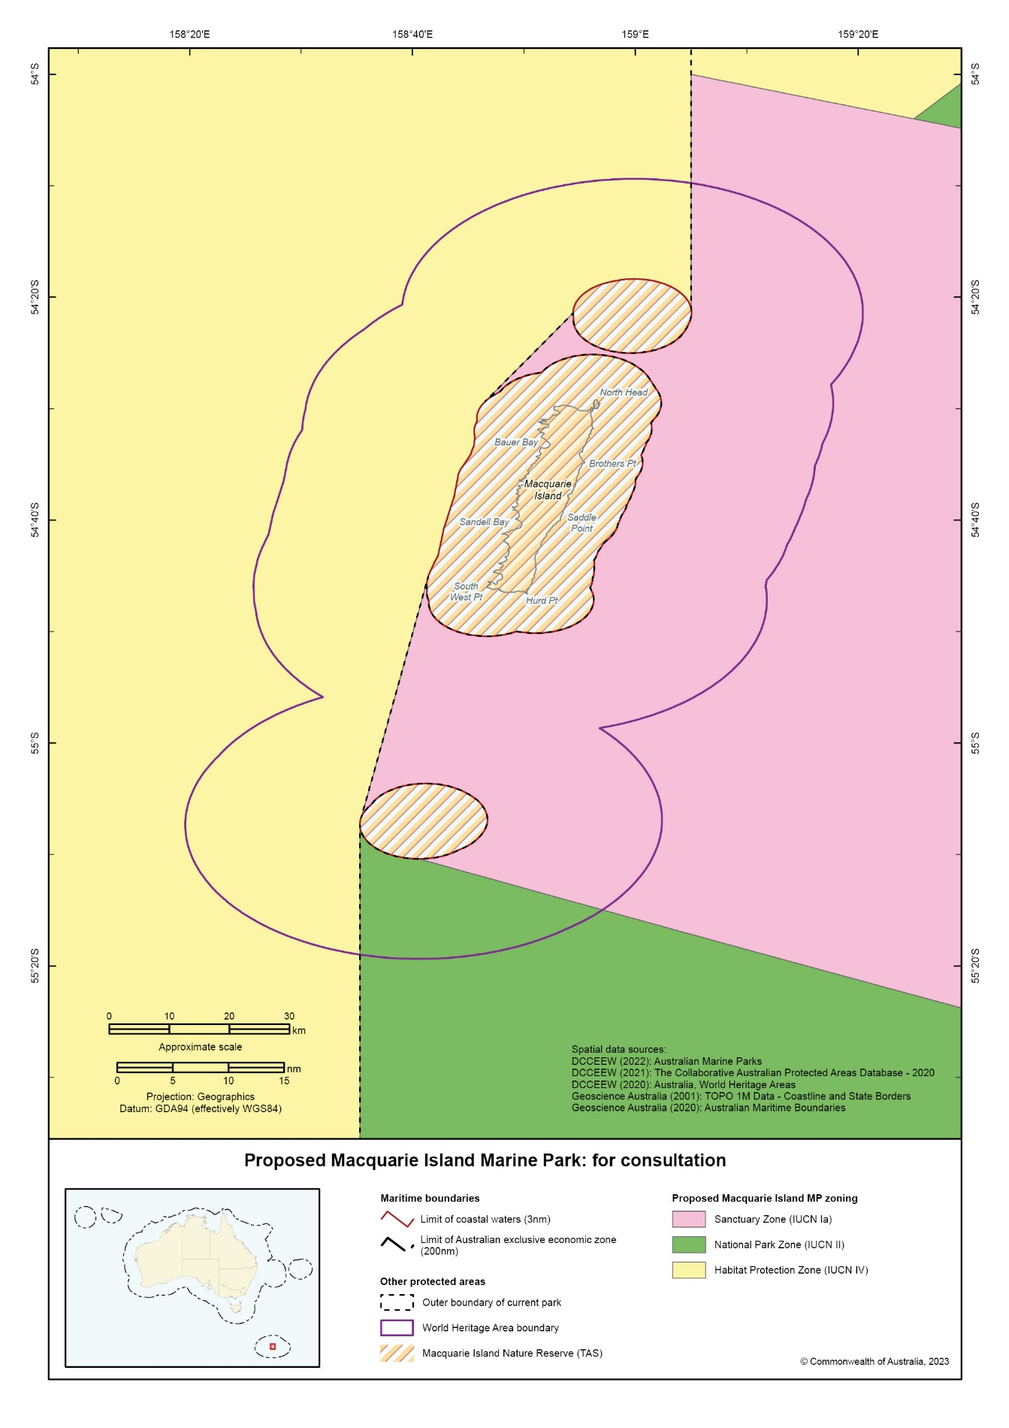

# The process required to expand Macquarie Island Marine Park

It is proposed that the current protections for the waters surrounding Macquarie Island are altered through both:

* the incorporation of a new area; and
* amending zoning within the current marine park.

The expansion of Macquarie Island Marine Park is provided for by the EPBC Act under sections 344 and 350, which enables alterations of Commonwealth reserves and new proclamations. The intended process is to amend the existing marine park to incorporate a new adjacent area of sea and reassign some of the existing zones to different IUCN categories, subject to the outcomes of this consultation.

This would establish a single Macquarie Island Marine Park that includes the current park area, as well as any new area and any internal zoning changes made on the basis of this consultation.

# Rationale to expand Macquarie Island Marine Park

The proposed expansion of the Macquarie Island Marine Park would protect in a wilderness area of our ocean that is of high conservation value, critical to many species, including threatened and endemic ones, and vulnerable to a changing climate. It has also been subject to relatively low levels of extractive use—including at present—which makes a significant increase in protection possible without displacing current users.

The Macquarie Island Marine Park was first proclaimed in 1999, and its design has not been modified in over two decades. The marine park was initially managed under its own management plan from 2001-2008, then incorporated into the *South-east Marine Parks Network Management Plan 2013-2023* with no substantial changes to park design. Since the 1999 proclamation, knowledge of the area has increased considerably.

Macquarie Island is one of only two marine parks in the Southern Ocean within Australia’s jurisdiction (the other being the Heard Island and McDonald Islands Marine Reserve). The marine park is critically important to the South-east Network and the *NRSPMA* as it is the only representative example of the Macquarie Province bioregion.

The Macquarie Province bioregion includes an area of 477,430km2 and a maximum depth of 6,737 metres. The bioregion is described as:

“An extremely isolated fragment of mid-oceanic ridge (Macquarie Rise) uplifted above sea level in the Miocene. The bioregion has a distinctive sub-Antarctic flora and fauna with a high proportion of endemic algal and invertebrate species. The deep-water fauna is closely allied biogeographically to the fauna of the New Zealand sub-Antarctic islands and has probably migrated to the island along the Macquarie Ridge (IMCRA v4.0).”

Macquarie Island represents an exposed section of the Macquarie Ridge, one of the world’s great oceanic ridges (further description at Section 5). The unique geographic characteristics formed the basis for Macquarie Island, coastal waters and its territorial sea to be designated as a World Heritage Area in 1997.

The Macquarie Island World Heritage Area is one of 20 Australian sites listed under the World Heritage Convention for its Outstanding Universal Values. All World Heritage properties in Australia are recognised as ‘matters of national environmental significance’ under the EPBC Act. There is overlap between the World Heritage Area and the current Macquarie Island Marine Park on the eastern side of the island. However, the marine park currently does not extend to the World Heritage Area waters from 3 nautical miles to 12 nautical miles on the western side of the island. The Tasmanian Government’s *Macquarie Island Nature Reserve and World Heritage Area Management Plan 2006* stated that complementary management across the adjacent Australian and New Zealand jurisdictions near Macquarie Island could make a significant contribution to marine conservation in the Southern Ocean.

There are strong ecological links between terrestrial and marine environments in the Macquarie Island region. For the approximately 50 species of seabirds, four species of penguins and four species of seals which rely on both Macquarie Island and the surrounding waters for certain stages of their lives, the current area represents only a small portion of the marine ecosystems of which they are a part. The region includes 28 threatened species listed under the EPBC Act. Two species, the royal penguin and Macquarie Island imperial shag are endemic to Macquarie Island, meaning they do not occur anywhere else. Expanding the marine park would benefit these and other species that are dependent on a healthy ocean to breed, feed and migrate. Many of the species in the region require extremely large migratory or foraging ranges and would benefit from protection of these ecologically important habitats.

Sub-Antarctic regions are increasingly the focus of global conservation efforts, as the Southern Ocean is understood to play a critical role in regulating currents and climate patterns (State of the Environment Report 2021). Ocean temperatures in the region have slowly increased due to the absorption of carbon dioxide from the atmosphere. With increases in sea surface temperatures, increases in ocean acidification, strengthening of winds and the impacts of sea ice melts, the region has been described as particularly vulnerable to a changing climate (State of the Environment Report 2021). Species that inhabit the sub-Antarctic waters in the Southern Ocean are often at the edge of their range and under threat due to low resilience and slow rates of recovery (Kaiser et al. 2013; Clark et al. 2015). Incorporating the surrounding waters presents an opportunity to manage current pressures and monitor trends to better understand and build resilience of the important species and communities.

The proposed expansion would ensure that important habitats, species and sites of ecological and cultural significance are protected, while minimising social and economic impacts on marine based industries and other marine park users.

The proposed expansion aims to:

* Protect the entirety of the Macquarie Province bioregion within Australia’s EEZ.
* Ensure all marine areas of the Macquarie Island World Heritage Area are under marine park protection.
* Expand protection of important areas for breeding and foraging threatened and migratory species.
* Support the inclusion of seafloor features (such as geomorphic features) in the marine park. An expanded marine park would include the entire portion of the Macquarie Ridge that lies within Australia’s EEZ.
* Achieve the dual objectives of protecting and conserving biodiversity, while supporting compatible ecologically sustainable use by enabling the continuation of a sustainable fishery aligned with its historical footprint.

The proposed expansion would provide continuous management across State and Commonwealth waters and would protect the entire EEZ around Macquarie Island.

Final design of the marine park will be informed by public comments received during the 60-day statutory consultation period in response to the release of this draft proposal.

# Natural Values

## Geology and oceanography

The waters surrounding Macquarie Island are isolated, unique and have a range of natural features in depths over 6000 metres. The Macquarie Ridge is one of the world’s great oceanic ridges and forms a major transform plate boundary. It is where the Indian-Australian tectonic plate interacts with the Pacific plate (Christodoulu et al. 1984). The Macquarie Ridge stretches approximately 1,600 km north-south through the centre of the region and interacts with the strong oceanic fronts to create several distinct oceanographic sections of the region (Conway et al. 2012). The ridge is nearly 6,000 meters tall and only 40 km wide—one of the steepest examples of underwater topography of that vertical scale on Earth (Tkalčić et al. 2021). Macquarie Island itself represents an exposed section of the ridge and is the only place on Earth where a section of oceanic crust and mantle rock known as an ophiolite is exposed above the ocean basin in which it originally formed (Commonwealth of Australia 1996).

Oceanographically, the Macquarie Ridge acts as a major barrier to the Antarctic Circumpolar Current, the Earth’s largest and most important oceanic current. The current’s spatial variation, largely affected by seasonal dynamics, impacts on the balance of oceanic and atmospheric heat and chemical exchange, which in turn has an effect on the southern hemisphere’s climatic budget (AGSO, pers.comm; State of Environment Report 2021).

The Macquarie Ridge (running north-south) represents a transition zone, with many species being at the southern or northern limit of their range. Within the region there are complex interactions among the ridge, oceanic fronts and depth-stratified currents that support a rich composition of species with a variety of regional affinities (Butler et al. 2000). The two major oceanic fronts in the region are the Sub-Antarctic Front and the Polar Front. The interaction between the ridge and the fronts suggests there are portions of at least six different large-scale oceanographic habitats in the region (Commonwealth of Australia 2001).

Around 49% of the current marine park has been mapped using high-resolution multibeam echo sounder from depths of 500 metres to the abyssal plain at 6000 metres. The mapping has focused mainly on the western side of the region. There has been some mapping of areas outside the park.

**Figure 6- Map of the proposed Macquarie Island Marine Park displaying the currents, fronts and geomorphic features**

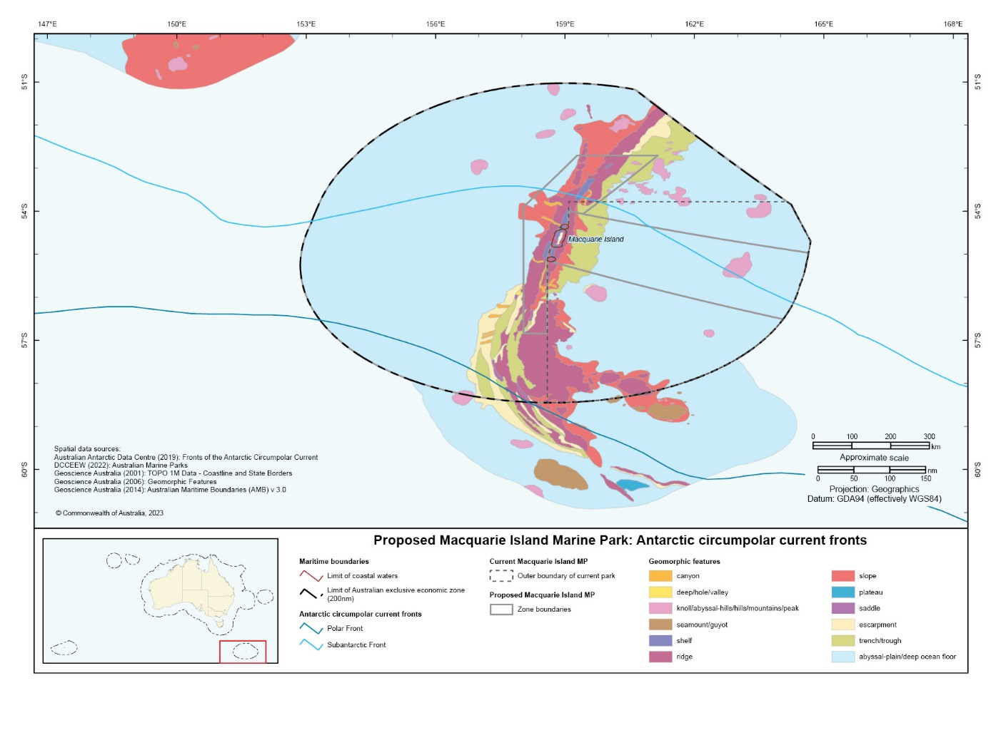

## Benthic habitat and communities

Understanding of the benthic habitat and communities in the region has increased considerably in the past two decades. However, the knowledge base is still relatively low.

The ecosystem complexes, defined in the National Environmental Science Program (NESP) report ‘*Designing a targeted monitoring program to support evidence-based management of Australian Marine Parks’*, for the current Macquarie Island Marine Park include shelf unvegetated soft sediments, upper slope unvegetated soft sediments, mid and lower slope soft sediments, abyssal plain (reef and soft sediments), seamounts and canyons (Hayes et al. 2021).

The known benthic features and associated ecological communities within the EEZ include ridges, canyons, seamounts, knolls, escarpments, slopes, trenches and abyssal plains.

The Macquarie Ridge is notably the most studied feature in the region. Along the Macquarie Ridge, surveys show assemblages of sponges, stony corals, gorgonians, echinoderms and crustaceans, mainly on the top of the ridge north and south of Macquarie Island (Koslow and Kloser 1999). Previous benthic surveys conducted along the ridge observed considerable heterogeneity. They identified that the benthic environment in the troughs and canyons was comprised of typical soft-bottom fauna with minimal stony corals present.

Several seamounts have been observed within the EEZ surrounding Macquarie Island. Seamount ecosystems are known hotspots of biodiversity and may be important sites for evolution (O’Hara 2007).

A research voyage in 2008 provided the most extensive data on the benthic habitat and communities in the region. The voyage surveyed five seamounts distributed throughout Australia’s EEZ around Macquarie Island ranging from depths of 90 metres to 2500 metres. Through Deep-Towed Imaging Systems, areas of abundant sponge and coral (gorgonian and soft coral) cover have been found on these seamounts (Rowden et al. 2008). These include bubblegum corals, gorgonian fans, bottlebrush corals, and stylasterids. Two seamounts south of Macquarie Island were identified as habitats for species of squat lobsters, with samples collected between depths of 501–775 metres.

Squat lobsters have an important trophic role in food webs as both recyclers of organic matter and being consumed by top predators (Lovrich and Thiel, 2011). They are often recorded on seamounts and plateaus, however, there is limited amount of suitable habitat in the subantarctic. The Macquarie Ridge seamounts are 5000 km from the nearest suitable habitat on the Kerguelen Plateau. With limited opportunities for dispersal and isolation-by-distance these seamounts provide critical habitat for the squat lobsters (Schnabel et al.2017).

The benthic habitat in the region is inhabited by sponges, echinoderms, deep-sea corals and hydroids. Deep-sea communities like these often have low resilience to disturbance and have slow rates of recovery (Kaiser et al. 2013; Clark et al. 2015).

Within the South-east, the Macquarie Island region has distinct ecology and is often described as a ‘stepping stone’ that links the subantarctic and polar fauna. Elements from several faunal regions (such as south-eastern Australia, southern New Zealand, other subantarctic waters and Antarctica) are present around Macquarie Island, many species being at the far southern or northern end of their range (Butler et al. 2000). Previous work has indicated that the region surrounding Macquarie Island is area where multiple characteristic epibenthic invertebrate communities converge (Dell et al. 2016).

Several studies have explored the benthic communities in the region. O’Hara et al. (2013) found that the region shares many ophiuroid (brittlestar) species with Southern Australia and New Zealand and a smaller number with sub-Antarctic and Antarctic locations. The Antarctic Circumpolar Current acts as a barrier to gene flow for some coral communities in the region, separating populations of deep-sea octocorals between the north (around New Zealand and Tasmania) and south (Southern Ocean) (Duenas et al. 2016; Zeng et al. 2017). The north-central-south population differentiation that is observed in corals has also been observed in sponges, potentially due to oceanic currents and fronts converging in the region (Zeng et al. 2019).

## Pelagic habitat and fauna

Situated close to the Antarctic Convergence, where the nutrient-rich waters of the Southern Ocean meet warmer waters, rich feeding grounds make Macquarie Island and Macquarie Island Marine Park important for approximately 3.5 million seabirds and 100,000 seals that breed and forage in the region. This includes 28 threatened species that inhabit the marine environments, and 39 marine species listed under the EBPC Act. Several of these species are not found anywhere else in the world.

The nutrient-rich waters in the Macquarie Island region can be attributed to the convergence and mixing of currents and fronts. The primary productivity levels are high in the area between the sub-Antarctic and Polar Fronts (Sokolov and Rintoul, 2007). The nutrient rich waters contribute to greater productivity including prey species for seals and seabirds that forage in the area.

### Seabirds

The Macquarie Island region supports large congregations of seabirds, comprising approximately 50 species. Within the region there are 22 seabird species that are listed as threatened under the EPBC Act, including the black-browed albatross, grey-headed albatross, wandering albatross, southern giant petrel and northern giant petrel (see Appendix A). For the wandering albatross and grey-headed albatross, Macquarie Island has been identified as Critical Habitat under section 207 of the EPBC Act. The island supports breeding populations of seven species listed under the international Agreement on the Conservation of Albatrosses and Petrels (ACAP), to which Australia is a signatory, whilst the broader region provides foraging habitat for many other ACAP-listed species. The Macquarie Island imperial shag is endemic to Macquarie Island.

Many of the seabirds in the region depend on the pelagic waters for foraging. The EEZ surrounding Macquarie Island is a biologically important foraging area for the black-browed albatross, Campbell albatross, Indian yellow nosed albatross, and the Antipodean albatross (Parks Australia 2022). Several species have been observed to forage in the waters outside of the current marine park boundary (Terauds et al. 2006 ; Trebilco et al. 2008; Cleeland et al. 2019).

Four penguin species (gentoo, king, rockhopper, royal penguin) breed at Macquarie Island and forage in the nearby productive waters (Hull 1999; Robinson and Hindell 1996; Wienecke and Robertson 2002). The endemic royal penguin has an estimated population of approximately 750,000 breeding pairs (Salton et al. 2019). There are recorded populations of royal penguins on both the western and eastern sides of the island (Salton et al. 2019).

Macquarie Island is the only breeding site for king penguins and gentoo penguins in the Pacific sector of the Southern Ocean (Bost et al. 2013). For gentoo penguins it represents one of just two breeding sites within Australia’s jurisdiction (Pascoe et al. 2020).

The penguin species use different foraging areas and strategies. The gentoo and rockhopper penguins forage in more benthic inshore environments. However, gentoo penguins have been recorded to forage up to 53 km from breeding locations (Robinson and Hindell 1996). The king and royal penguins are more specialist pelagic foragers, often preying on krill, fish and squid (Gilmour et al. 2019). King penguin diving depths have been recorded between 60 metres to 300 metres (Wienecke and Robertson 2002). Royal penguin foraging activity is typically in offshore environments (over 600km from Macquarie Island), in deep water (greater than 2000m) and associated with the Polar Front (Hull et al. 1997). The association with the Polar Front may be due to the enhanced productivity in the area.

### Marine mammals

The region provides breeding and foraging grounds for southern elephant seals, Long-nosed fur seals, Antarctic fur seals and Sub-Antarctic fur seals. It presents the only sub-Antarctic island where they are all present together (Goldsworthy et al. 2009). Non-breeding New Zealand sea lions and leopard seals are also regularly observed resting or feeding in the area.

The island is important for southern elephant seals as it supports 10% of the global population (Tasmania Parks and Wildlife Service, 2022). The Macquarie Island stock of southern elephant seals has been steadily declining over several decades (Hindell et al. 2017). Several studies suggest this is likely a result of changes in food availability, habitat changes and environmental changes (McMahon, Bester, Burton, Hindell, and Bradshaw, 2005; Hindell et al. 2016; Hindell et al.2017).

The pelagic waters support the seasonal use of a number of cetaceans including killer whales, sperm whales and long-finned pilot whales. Killer whales are the most common cetacean species observed in offshore waters, particularly around the time when young seals and penguins go to sea for the first time (Travers et al. 2018). There have been 13 cetacean species either sighted or stranded in the region (Clarke et al. 2017), although it should be noted that most observations have been recorded from on shore at Macquarie Island, therefore there may be other species using the further offshore environments for foraging and migration.

### Fish

The benthic and pelagic fish distribution in the Southern Ocean has been documented by Duhamel et al. (2014), and they defined the Macquarie Island region as the West Pacific within the Sub-Antarctic Region. Species distribution in the Southern Ocean follows the characteristics of water masses and annular frontal systems. In the pelagic waters surrounding Macquarie Island the fish distribution is separated into a temperate sub-group to the north of the Sub-Antarctic Front and the polar subgroup to the south. Biomass of some species of fish are enhanced where the Sub-Antarctic Front interacts with the Macquarie Ridge (Flynn and Williams 2012).

Patagonian toothfish are present in the waters surrounding Macquarie Island. The species is widely distributed inhabiting the continental shelf waters of sub-Antarctic islands, oceanic ridges and the southern South American continent (Appleyard et al. 2002). Patagonian Toothfish are the target species for the Macquarie Island Toothfish Fishery. Genetic studies and toothfish tagging programs indicate that the toothfish population around Macquarie Island is considered to be distinct from other populations in the Southern Ocean (Appleyard et al. 2002; Patterson et al. 2022).

## World Heritage Area (Macquarie Island and coastal habitat)

The Macquarie Island World Heritage Area was listed in 1997 for Outstanding Universal Values under two criteria of the World Heritage Convention:

*Criterion (vii) to contain superlative natural phenomena or areas of exceptional natural beauty and aesthetic importance; and*

*Criterion (viii) to be outstanding examples representing major stages of earth’s history, including the record of life, significant on-going geological processes in the development of landforms, or significant geomorphic or physiographic features.*

Macquarie Island Nature Reserve and World Heritage Area is globally recognised for its conservation, geological, ecological and scientific values.

Macquarie Island is a site of major geoconservation significance as it provides evidence of rock types found at great depths in the earth’s crust. The island and islets support vast congregations of wildlife and provide critical breeding and foraging habitats for large numbers of species. The island also supports arrays of subantarctic vegetation including the critically endangered Macquarie Cushions, Subantarctic Bedstraw, Grooved Helmet-orchid and the Windswept Helmet-orchid.

The terrestrial and marine environments of the Macquarie region are inextricably linked. Protection of the marine environment would support many of the values within the reserve and World Heritage Area (Parks and Wildlife Service, 2006). An expanded marine park would also provide continuous management across the terrestrial, coastal and marine areas.

# Integrating social, cultural and economic values in park planning

## Background

Macquarie Island has a rich history, being one of the earliest European occupied sites in Australia. Sealing sites, expedition sites and shipwreck material of significant cultural value remain on and around Macquarie Island. Despite the historical presence of the blubber oil industry, the remote and deep offshore waters that surround Macquarie Island have limited economic activities and associated pressures, compared with other areas of Commonwealth waters adjacent to mainland Australia.

Once commercially exploited for seal and penguin oil in the 19th and early 20th centuries, the primary use of Macquarie Island and surrounding waters is now focussed on conservation and scientific research. Exploitation of seals and penguins had devastating effects on stocks, with some species recorded to have been eradicated entirely (Townrow 1988).

Within the offshore marine environment lies the shipwreck of *Nella Dan*, a resupply and research ship that played a pioneering role in the development of Australia’s Antarctic research program (CSIRO 2020). The ship was scuttled in 1987 in 5000m of water at the bottom of a steep slope that runs from Macquarie Island down to the deep ocean.

It is not known whether any First Nations Australians have cultural connections to the waters surrounding Macquarie Island, or the species that use its waters.

## Activities

Due to its isolated position and current governance, visits to and surrounding the island are allowable by permit entry only. Tourism is limited as all travel is required by water, and apart from temporary influxes when supply or ships visit the island, the quotas for Educational Tourist Visits to the Macquarie Island Reserve are stipulated by Tasmania Parks and Wildlife Service, with a direct impact on the number of potential visitors transiting through the marine park.

Personnel from the Australian Antarctic Program work at the station on the Isthmus of the island. There has been a scientific presence on the island since the first permanent establishment in 1948, initiated by the Australian Government. The Tasmanian National Parks and Wildlife Service also have an active research and managerial role on the island, ensuring activities in the Macquarie Island Reserve are compliant with the Macquarie Island Nature Reserve and World Heritage Area Management Plan. Research, management, and long-term monitoring programs conducted over time have contributed to the current state of knowledge of the island and surrounding waters, and to better understand global earth processes by developing global monitoring programs.

### Macquarie Island Toothfish Fishery

The Macquarie Island Toothfish Fishery is the only contemporary extractive activity in the waters surrounding Macquarie Island. The fishery has been operating since 1994 and is a respected, well-regulated and highly sustainable toothfish fishery.

Demersal trawl was once the sole fishing method for commercial operators within the Australian Fishing Zone of Macquarie Island with up to two fishing vessels operating in the fishery. A trial of demersal longline fishing gear commenced in 2007 resulting in longlining being added as an approved fishing method in 2011. Demersal longline has been the only fishing method used since 2009. Two companies currently hold statutory fishing rights to operate in the Commonwealth managed Macquarie Island Toothfish Fishery, and a maximum of three vessels can operate in the fishery. A single fishing vessel has fished in the fishery in recent years.

Historically the fishery has targeted aggregations of toothfish occurring at many locations along the Macquarie Ridge, as well as the Aurora Trough, a long depression immediately west of Macquarie Island (Tuck et al. 2013).

Although the Macquarie Island Toothfish Fishery sits outside the area of competency of the Commission for the Conservation of Antarctic Marine Living Resources (CCAMLR), the Australian Fisheries Management Authority (AFMA) requires that fisheries in waters adjacent to the CCAMLR area, which includes Macquarie Island, are managed in a complementary manner to the CCAMLR requirements. The management of the fishery is consistent with the precautionary approach of the Commission for the Conservation of Antarctic Marine Living Resources and is considered more precautionary than the guidelines of the Commonwealth Fisheries Harvest Strategy Policy.

The Macquarie Island Patagonian toothfish stock has been assessed by the Australian Bureau of Agricultural and Resource Economics as not over fished and not subject to overfishing (Patterson et al. 2022). The management of the fishery is certified as sustainable by the Marine Stewardship Council, an international independent, third-party assessor, with a recent report following an audit conducted in 2022 confirming that the fishery continues to meet the Marine Stewardship Council Fisheries Standard (Bio.inspecta 2022).

There has been considerable research conducted in the fishery since its inception. This has enabled a greater understanding of the habitats, species and stocks. The fishery releases annual research statements and five-yearly research plans. There is also 100% observer coverage during the fishing season to monitor bycatch and interactions with other species. The Commonwealth waters around Macquarie Island have no history of other extractive activities such as mining, aquaculture and recreational use. This provides a rare opportunity to expand protection without disrupting existing activities.

# Pressures

## Changing climate

The State of the Environment Report 2021 identified the Southern Ocean as critical in regulating currents and climate patterns.

The sub-Antarctic oceanic region has experienced increases in sea surface temperatures due to the absorption of carbon dioxide from the atmosphere. This increase in sea surface temperature alongside increases in ocean acidification, strengthening of winds and the impacts of sea ice melts has meant the region is often described as particularly vulnerable to a changing climate (State of the Environment Report 2021).  Changes in the climatic conditions in the sub-Antarctic may negatively impact the species exclusively found in these waters as well as species that have already shifted to their southern range limit (Kaiser et al. 2013).

## Human activity

### Shipping and vessel transit

Shipping and other transiting vessels such as tourism or fishing vessels have the potential to cause an incursion of marine invasive species or marine pollution. The Tasmanian *Macquarie Island Nature Reserve and World Heritage Area Management Plan 2006* includes strict measures to limit the risk of biosecurity incursions to the island (Parks and Wildlife Service, 2006). Australia is a party to a number of international agreements relevant to shipping and vessel transit including United Nations Convention on the Law of the Sea (UNCLOS) and the International Convention for the Prevention of Pollution from Ships (MARPOL). UNCLOS provides a right of innocent passage through the territorial sea for foreign vessels, and right of freedom of navigation through Australia’s EEZ. MARPOL deals with the preservation of the marine environment through the prevention and minimization of pollution from ships.

### Research and Monitoring

Research and monitoring activities have the potential to cause harm to the marine environment depending on the methodology and procedures used. Within Australian Marine Parks, research and monitoring activities are allowable subject to assessment, in accordance with a permit, class approval or activity licence or lease issued by the Director of National Parks. Research and monitoring carried out within the fishery is currently managed by AFMA, the Fisheries Research and Development Corporation and the Australian Antarctic Division.

### Commercial fishing

The Macquarie Island Toothfish Fishery is a well-managed sustainable, limited entry fishery with strict management arrangements in place to minimise any impact on the environment, including world’s best practice measures to avoid incidental catch of seabirds and non-target marine species. The Macquarie Island Toothfish Fishery is accredited under part 13 of the EPBC Act and has export approval under part 13A. An ecological risk assessment undertaken for the fishery found that no target, bycatch, byproduct or protected species were considered to be at high risk from the effects of fishing given the suite of management and conservation initiatives in place.

# 5. Proposed Macquarie Island Marine Park design

## Macquarie Island Marine Park design

The proposed expansion of Macquarie Island Marine Park would increase the protection and conservation afforded to biodiversity and other natural, cultural and heritage values. A portion of the park would continue to allow sustainable fishing under AFMA’s fisheries management arrangements.

The design proposed for Macquarie Island Marine Park comprises a total area of 475,465 km2, which would increase the existing marine park by 313,465 km2 (see Figure 7), almost a 300% increase from the previous marine park area. The full Australian EEZ around Macquarie Island would become a part of the marine park, with coverage extending from 3 nautical miles from the shoreline.

It is proposed that the existing Sanctuary Zone (IUCN Ia) remain in place, in light of its value as an important foraging ground for seabirds, seals and penguins that breed on the island. Most areas of the previous Habitat Protection Zones (IUCN IV), in addition to the new park area would become National Park Zones (IUCN II), extending right to the State waters on the western side of Macquarie Island. A new Habitat Protection Zone (Macquarie IUCN IV) would be established to allow for continued sustainable fishing. This design proposes that 12% of the marine park would be protected by a Sanctuary Zone, 82% would be protected by National Park Zones, and 6% by the Habitat Protection Zone.

**Figure 7- Proposed design for the expanded Macquarie Island Marine Park, with co-ordinates**

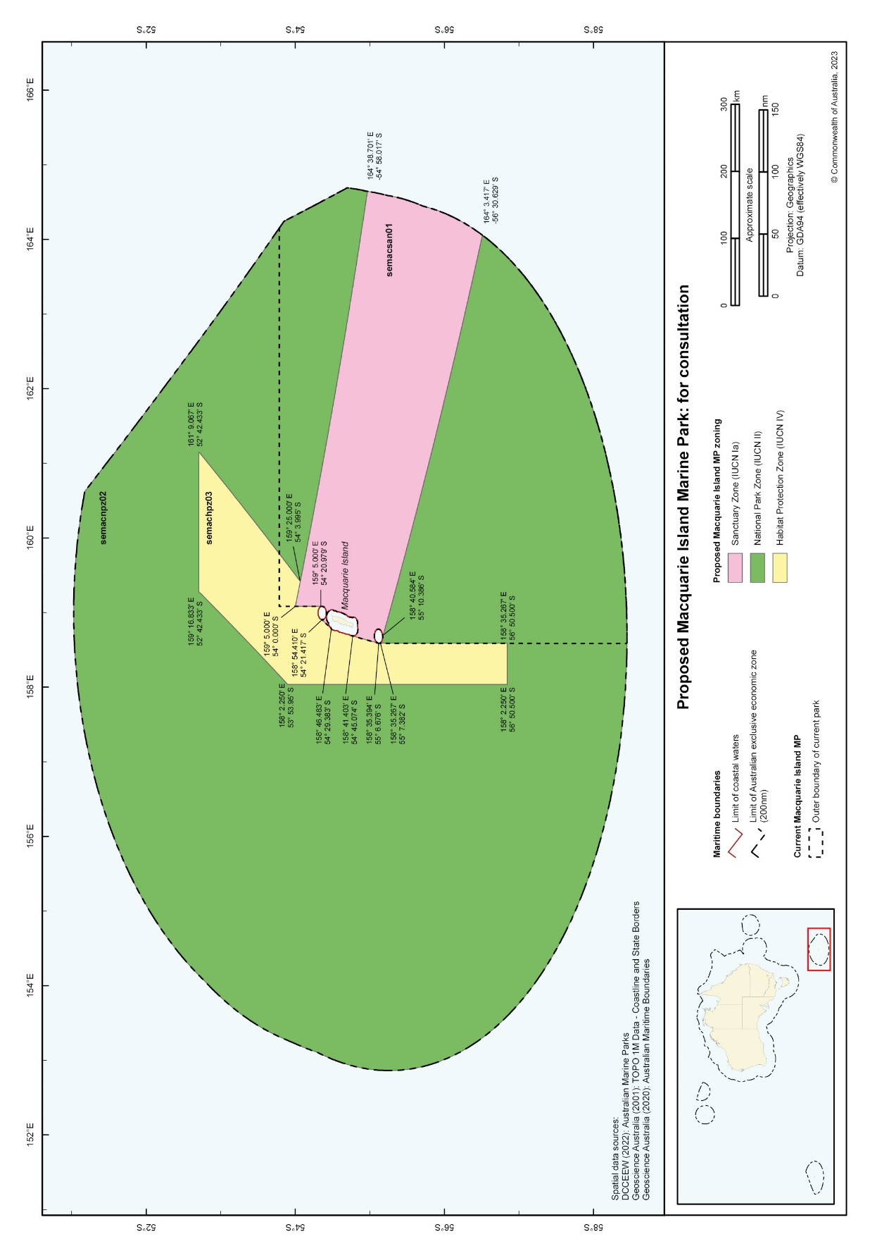

## Zoning for the proposed expanded Macquarie Island Marine Park

The EPBC Actprescribes the legal requirements for establishing AMPs in Commonwealth areas (for areas of land and sea). Among other requirements, this includes assigning an International Union for the Conservation of Nature (IUCN) protected area category to parks and (if applicable) the zones within them.

Zoning of marine parks seeks to achieve the specific purpose or objectives of a particular marine park. Different zoning puts different limits to what types of activities can and cannot occur.

The IUCN category assigned to the proposed expanded Macquarie Island Marine Park is National Park Zone (IUCN category II).

The proposed Macquarie Island Marine Park would be divided into zones and assigned to the IUCN categories below:

### (a) Sanctuary zone (IUCN category Ia)

To be managed to conserve ecosystems, habitats and native species in as natural and undisturbed a state as possible. The zone allows only authorised scientific research and monitoring.

### (b) National Park Zone (IUCN category II)

To be managed to protect and conserve ecosystems, habitats and native species in as natural a state as possible. The zone only allows non-extractive activities unless authorised for research and monitoring.

### (c) Habitat Protection Zone (Macquarie) (IUCN category IV)

To be managed to protect the pelagic habitats in the waters surrounding Macquarie Island. The zone aims to ensure the maintenance of ecosystems, habitats and native species through sustainable resource management.

## Rationale for the proposed park design and zoning

It is proposed that the boundary of the expanded Macquarie Island Marine Park adjoin the existing Nature Reserve and World Heritage Area, to ensure habitat connectivity between the marine and terrestrial environments.

Examples of connectivity include:

* Foraging, breeding and migratory seabirds and marine mammals – Macquarie Island is home to numerous nesting seabirds and breeding marine mammals, including two endemic species, which rely on the surrounding waters to forage.
* Marine habitat connectivity - joining the marine park to the existing World Heritage marine area means that all water depths and the habitats within the region would be protected.

The proposed expansion of Macquarie Island Marine Park represents an opportunity to protect both marine species and terrestrial species that are dependent on a healthy ocean to breed, feed and migrate.

### (a) Sanctuary zone (IUCN category Ia)

This current zone would be maintained in its full extent to minimise disturbance to the environment from human activities. A number of species found in the Macquarie Island region, including five albatross species, four penguin species and four seal species, are recognised as threated under Australian law and in some cases, international conventions. As most of these species require extremely large migratory or foraging ranges, protection of their critical feeding and migratory areas around Macquarie Island and the broader South-east marine region has international significance.

### (b) National Park Zone (IUCN category II)

The large National Park Zone has been proposed to preserve the unique, relatively undisturbed marine environment surrounding Macquarie Island. The National Park Zone would include representative examples of features including seamounts, canyons and abyssal plains. Some of these waters may have been subject to limited commercial fishing historically, however there has been no mining or other extractive activities. The National Park Zone would allow for low-impact scientific research activities to occur, to improve understanding of the region and its values.

### (c) Habitat Protection Zone (Macquarie) (IUCN category IV)

The Habitat Protection Zone was originally designated to protect the pelagic environment, which provides important foraging and migratory functions for seabirds, penguins, and marine mammals. The current Habitat Protection Zones of Macquarie Island Marine Park allow demersal longline and other demersal fishing methods to occur in accordance with a ‘class approval’[1], where they do not significantly impact on the pelagic habitat values. This approach varies from other Habitat Protection Zones in the Australian Marine Parks network, which are designed to protect benthic habitats. Consistent with the current arrangements in the broader South-east Network, demersal trawl would not be an allowed activity.

**Table 3- Overview of proposed activity prescriptions for Macquarie Island Marine Park**

|  |  |  |  |
| --- | --- | --- | --- |
| **Activity** | **Sanctuary Zone (IUCN Ia)** | **National Park Zone (IUCN II)** | **Habitat Protection Zone (Macquarie) (IUCN IV)** |
| Recreational and subsistence fishing (including anchoring) | 🗶 | 🗶 | 🗶 |
| General use, access and waste management | 🗶 | ✓ | ✓ |
| Commercial shipping | 🗶 | ✓A | ✓A |
| Commercial fishing | 🗶 | 🗶A | ✓B |
| Aquaculture | 🗶 | 🗶 | 🗶 |
| Commercial media | ✓B | ✓B | ✓B |
| Commercial tourism (e.g. nature watching) | 🗶 | ✓B | ✓B |
| Mining (e.g oil and gas extraction) | 🗶 | 🗶 | 🗶 |
| Renewable energy | 🗶 | 🗶 | 🗶 |
| Structures and works | ✓B | ✓B | ✓B |
| Research and monitoring | ✓B | ✓B | ✓B |

✓ Activity is allowed in accordance with the prescriptions of a management plan without the need of a permit, class approval or activity licence or lease issued by the Director of National Parks. The International Convention for the Prevention of Pollution from Ships (MARPOL) also applies with respect to ship generated pollution from ships (i.e. waste management).

🗶 Activity is not allowed.

A Anchoring is not allowed except in anchoring areas determined under r.12.56 of the EPBC Regulations.

B Activity is allowed, subject to assessment, in accordance with a permit, class approval or activity licence or lease issued by the Director of National Parks (DNP). Class approvals are a general authorisation that allows a commercial activity to continue (e.g. commercial fishing) under existing (non-marine park) approvals, without separate DNP approval or fees.

**Table 4- Overview of proposed commercial fishing activity prescriptions for Macquarie Island Marine Park**

|  |  |  |  |
| --- | --- | --- | --- |
| Commercial fishing  activity | Sanctuary Zone  (IUCN Ia) | National Park Zone  (IUCN II) | Habitat Protection Zone (Macquarie) (IUCN IV) |
| Dropline | 🗶 | 🗶 | 🗶1 |
| Hand collection (including using hookah, scuba, snorkel) | 🗶 | 🗶 | 🗶1 |
| Hand net (hand, barrier, skimmer, cast, scoop, drag, lift) | 🗶 | 🗶 | 🗶1 |
| Longline (demersal, auto-longline) | 🗶 | 🗶 | A |
| Longline (pelagic) | 🗶 | 🗶 | 🗶 |
| Minor line (handline, rod & reel, trolling, squid jig, poling) | 🗶 | 🗶 | 🗶1 |
| Net (demersal) | 🗶 | 🗶 | 🗶1 |
| Net (pelagic) | 🗶 | 🗶 | 🗶1 |
| Purse seine | 🗶 | 🗶 | 🗶1 |
| Trap, pot | 🗶 | 🗶 | A |
| Trawl (demersal) | 🗶 | 🗶 | 🗶 |
| Trawl (midwater) | 🗶 | 🗶 | 🗶1 |
| Trotline | 🗶 | 🗶 | 🗶1 |

x Activity is not allowed.

A Authorisation required. Activity is allowable, subject to assessment, in accordance with a permit, class approval or activity licence issued by the Director.

🗶1 Activity is not allowed. Activity may be currently allowed under the South-east Class Approval but is considered inconsistent with pelagic protection.

**Table 5- Summary of key information for the proposed Macquarie Island Marine Park**

|  |  |  |  |
| --- | --- | --- | --- |
| Name | Macquarie Island Marine Park | | |
| Area | 475,465km2 | | |
| Depth ranges | 86 to ~6,341m | | |
| Depth of reserve below seabed | 100 m | | |
| Latitude and currents | Antarctic Circumpolar Current | | |
| Sea Floor Features | Canyons, escarpment, knoll/abyssal hill, ridges, slope, seamounts,  trench/trough, abyssal plains | | |
| Ecosystem complex[2] | * Shelf unvegetated soft sediments * Upper Slope unvegetated soft sediments * Mid and Lower Slope soft sediments * Abyssal Plain (reef and soft sediments) * Seamounts * Canyons | | |
| Major conservation values | Examples of ecosystems, habitats and communities associated with:   * the Macquarie Province   The proposed marine park contains four Biologically Important Areas   * Black- browed albatross foraging * Campbell albatross foraging * Indian yellow nosed albatross foraging * Antipodean albatross foraging   The marine environment supports many other significant, threatened and keystone species and their habitats. These include:   * Numerous seabirds including black-browed albatross, grey-headed albatross, wandering albatross, southern giant petrel and northern giant petrel * Southern elephant seal * Antarctic seal * Sub-Antarctic seal * Long-nosed fur seals * Royal, king, rockhopper and gentoo penguins | | |
| Social, Cultural and Economic Values | Commercial fishing and research are important uses of the waters surrounding Macquarie Island. There is one commercial fishery that operates in the proposed marine park, the Macquarie Island Toothfish Fishery targets Patagonian toothfish and is managed by the Australian Fisheries Management Authority. Other activities in the area include transiting, shipping and tourism.  The shipwreck of Nella Dan, a resupply and research ship used by Australia’s Antarctic research program lies within the proposed marine park.  It is not known whether any First Nations Australians have cultural connections to the waters surrounding Macquarie Island, or the species that use its waters. | | |
| IUCN category | II – National Park Zone | | |
| Internal zoning proposed  Note that waters within 3nm of Macquarie Island are not included in the marine park | IUCN Ia  Sanctuary Zone  (57 137km2) | IUCN II  National Park Zone  (388 815 km2) | IUCN IV    Habitat Protection Zone  (29 514 km2) |

# 8. Acronyms

ACAP – Agreement on the Conservation of Albatrosses and Petrels

AFMA – Australian Fisheries Management Authority

AMP – Australian Marine Park

CCAMLR – Commission for the Conservation of Antarctic Marine Living Resources

DCCEEW- Department of Climate Change, Energy, the Environment and Water

DNP – Director of National Parks

EEZ – Australia’s Exclusive Economic Zone

EPBC Act – *Environment Protection and Biodiversity Conservation Act 1999 (Cth)*

IMCRA – Integrated Marine and Coastal Regionalisation of Australia

IUCN – International Union for the Conservation of Nature

MARPOL – International Convention for the Prevention of Pollution from Ships

NESP – National Environmental Science Program

NRSMPA – National Representative System of Marine Protected Areas

UNCLOS – United Nations Convention of the Law of the Sea

# 9. References and further reading

Appleyard, S.A., Ward, R.D. and Williams, R., 2002. Population structure of the Patagonian toothfish around Heard, McDonald and Macquarie Islands. *Antarctic Science*, *14*(4), pp.364-373.

bio.inspecta 2022. Macquarie Island Toothfish Fishery.  Public Certification Report

Bost, C.A., Delord, K., Barbraud, C., Cherel, Y., Pütz, K. and Cotté, C., 2013. King Penguin. Penguins: natural history and conservation.

Butler, A.J., Williams, A., Koslow, J.A., Gowlett-Holmes, K., Barker, B.A.J., Lewis, M. and Reid, R., 2000. A study of the conservation significance of the benthic fauna around Macquarie Island and the potential impact of the Patagonian Toothfish trawl fishery.

Christodoulou, C., Griffin, B., and Foden, J., 1984. The Geology of Macquarie Island. ANARE Research Notes 21.

Clark, M.R., Althaus, F., Schlacher, T.A., Williams, A., Bowden, D.A. and Rowden, A.A., 2016. The impacts of deep-sea fisheries on benthic communities: a review. ICES Journal of Marine Science, 73(suppl_1), pp.i51-i69.

Clarke, R.H. Gales, R and Schulz, M. 2017 Land-based observations of cetaceans and a review of recent strandings at sub-Antarctic Macquarie Island Australian Mammalogy, 39, 248–253 http://dx.doi.org/10.1071/AM16007

Cleeland J.B., Alderman R, Bindoff A, Lea M.A. et al. 2019 Factors influencing the habitat use of sympatric albatrosses from Macquarie Island, Australia. Mar Ecol Prog Ser 609:221-237. <https://doi.org/10.3354/meps12811>

Commonwealth of Australia, 1996. Nomination of Macquarie Island by the Government of Australia for inscription on the World Heritage List. Department of the Environment, Sport and Territories, Canberra

Commonwealth of Australia, 2001. Macquarie Island Marine Park Management Plan, 2001-2008, Environment Australia, Canberra.

Conway, C.E., Bostock, H.C., Baker, J.A., Wysoczanski, R.J. and Verdier, A.L., 2012. Evolution of Macquarie Ridge Complex seamounts: Implications for volcanic and tectonic processes at the Australia–Pacific plate boundary south of New Zealand. Marine Geology, 295, pp.34-50.

CSIRO, 2020. [Resting place of MV Nella Dan mapped during research into underwater earthquakes](https://www.csiro.au/en/news/news-releases/2020/resting-place-of-mv-nella-dan), Commonwealth Scientific and Industrial Research Organisation, accessed 6 March 2022.

Dell, J., Maschette, D., Sumner, M., and Welsford, D., 2016. Interactions between demersal fishing gears and macro-benthos around Macquarie Island. Hobart: Australian Antarctic Division.

Director of National Parks 2013, South-east Commonwealth Marine Reserves Network management plan 2013-23, Director of National Parks, Canberra.

Dueñas, L.F., Tracey, D.M., Crawford, A.J., Wilke, T., Alderslade, P. and Sánchez, J.A., 2016. The Antarctic Circumpolar Current as a diversification trigger for deep-sea octocorals. BMC evolutionary biology, 16, pp.1-17.

Duhamel, G., Hulley, P.A., Causse, R., Koubbi, P., Vacchi, M., Pruvost, P., Vigetta, S., Irisson, J.O., Mormede, S., Belchier, M. and Dettai, A., 2014. Biogeographic patterns of fish.

Flynn, A.J. and Williams, A., 2011. Lanternfish (Pisces: Myctophidae) biomass distribution and oceanographic–topographic associations at Macquarie Island, Southern Ocean. Marine and Freshwater Research, 63(3), pp.251-263.

Gilmour, M.E., Holmes, N.D., Fleishman, A.B. and Kriwoken, L.K., 2019. Temporal and interspecific variation in feather mercury in four penguin species from Macquarie Island, Australia. Marine pollution bulletin, 142, pp.282-289.

Goldsworthy, S.D., McKenzie, J., Page, B., Lancaster, M.L., Shaughnessy, P.D., Wynen, L.P., Robinson, S.A., Peters, K.J., Baylis, A.M. and McIntosh, R.R., 2009. Fur seals at Macquarie Island: post-sealing colonisation, trends in abundance and hybridisation of three species. Polar Biology, 32, pp.1473-1486.

Hayes, K.R., Dunstan, P., Woolley, S., Barrett, N., Foster, S., Monk, J., Peel, D., Hosack, G.R., Howe, S.A., Samson, C.R. and Bowling, R., 2021. Designing a targeted monitoring program to support evidence-based management of Australian Marine Parks: A pilot in the South-east Marine Parks Network.

Hindell, M.A., McMahon, C.R., Bester, M.N., Boehme, L., Costa, D., Fedak, M.A., Guinet, C., Herraiz‐Borreguero, L., Harcourt, R.G., Huckstadt, L. and Kovacs, K.M., 2016. Circumpolar habitat use in the southern elephant seal: implications for foraging success and population trajectories. Ecosphere, 7(5), p.e01213.

Hindell, M.A., Sumner, M., Bestley, S., Wotherspoon, S., Harcourt, R.G., Lea, M.A., Alderman, R. and McMahon, C.R., 2017. Decadal changes in habitat characteristics influence population trajectories of southern elephant seals. Global Change Biology, 23(12), pp.5136-5150.

Hull, C.L., Hindell, M.A. and Michael, K., 1997. Foraging zones of royal penguins during the breeding season, and their association with oceanographic features. Marine Ecology Progress Series, 153, pp.217-228.

Hull, C.L., 1999. The foraging zones of breeding royal (Eudyptes schlegeli) and rockhopper (E. chrysocome) penguins: an assessment of techniques and species comparison. Wildlife research, 26(6), pp.789-803.

Kaiser, S., Brandão, S.N., Brix, S., Barnes, D.K., Bowden, D.A., Ingels, J., Leese, F., Schiaparelli, S., Arango, C.P., Badhe, R. and Bax, N., 2013. Patterns, processes and vulnerability of Southern Ocean benthos: a decadal leap in knowledge and understanding. Marine biology, 160, pp.2295-2317.

Koslow, T. and R. Kloser. 1999. Cruise Report SS 01/99 : January 10 – February 4, 1999. Hobart, Tas: CSIRO Marine Research; <https://doi.org/10.4225/08/58712d755cf79>

Lovrich, G.A. and Thiel, M., 2011. Ecology, physiology, feeding and trophic role of squat lobsters. The biology of squat lobsters, 183, p.222.

McMahon, C.R., Bester, M.N., Burton, H.R., Hindell, M.A. and Bradshaw, C.J., 2005. Population status, trends and a re‐examination of the hypotheses explaining the recent declines of the southern elephant seal Mirounga eonine. Mammal Review, 35(1), pp.82-100.

O’Hara, T.D., 2007. Seamounts: centres of endemism or species richness for ophiuroids?. Global Ecology and Biogeography, 16(6), pp.720-732.

O’Hara, T.D., Smith, P.J., Mills, V.S., Smirnov, I. and Steinke, D., 2013. Biogeographical and phylogeographical relationships of the bathyal ophiuroid fauna of the Macquarie Ridge, Southern Ocean. Polar biology, 36, pp.321-333.

Parks and Wildlife Service, 2006, Macquarie Island Nature Reserve and World Heritage Area Management Plan, Parks and Wildlife Service, Department of Tourism, Arts and the Environment, Hobart

Pascoe, P., McInnes, J.C., Lashko, A., Robinson, S., Achurch, H., Salton, M., Alderman, R. and Carmichael, N., 2020. Trends in gentoo penguin (Pygoscelis papua) breeding population size at Macquarie Island. Polar Biology, 43, pp.877-886.

Patterson, H, Bromhead, D, Galeano, D, Larcombe, J, Timmiss, T, Woodhams, J and Curtotti, R 2022, Fishery status reports 2022, Australian Bureau of Agricultural and Resource Economics and Sciences, Canberra. CC BY 4.0. <https://doi.org/10.25814/gx9r-3n90>

Pratchett, M.S., and Pratchett, D. J. ,2021. Conservation Benefits of Large-Scale Marine Protected Areas (LSMPAs). Report to Parks Australia. Director of National Parks, Canberra

Robinson, S.A. and Hindell, M.A., 1996. Foraging ecology of gentoo penguins Pygoscelis papua at Macquarie Island during the period of chick care. Ibis, 138(4), pp.722-731.

Rowden, A.A. and Voyage Participants. 2008. Voyage Report. McRidge 2 - TAN0803. National Institute of Water and Atmospheric Research, New Zealand.

Salton, M., Kliska, K., Carmichael, N. and Alderman, R., 2019. Population status of the endemic royal penguin (Eudyptes schlegeli) at Macquarie Island. Polar Biology, 42(4), pp.771-781.

Schnabel, K.E., Burghardt, I. and Ahyong, S.T., 2017. Southern high latitude squat lobsters II: description of Uroptychus macquariae sp. nov. from Macquarie Ridge. Zootaxa, 4353(2), pp.327-338.

Sokolov, S. and Rintoul, S.R., 2007. On the relationship between fronts of the Antarctic Circumpolar Current and surface chlorophyll concentrations in the Southern Ocean. Journal of Geophysical Research: Oceans, 112(C7).

Terauds, A., Gales, R., Barry Baker, G. and Alderman, R., 2006. Foraging areas of black‐browed and grey‐headed albatrosses breeding on Macquarie Island in relation to marine protected areas. Aquatic Conservation: Marine and Freshwater Ecosystems, 16(2), pp.133-146.

Tkalčić, H., Eakin, C., Coffin, M., Rawlinson, N., and Stock, J., 2021, Deploying a submarine seismic observatory in the Furious Fifties, Eos, 102

Townrow, K., 1988. Sealing sites on Macquarie Island: an archaeological survey. In Papers and Proceedings of the Royal Society of Tasmania (Vol. 122, No. 1, pp. 15-25).

Travers, T., Van den Hoff, J., Lea, M.A., Carlyon, K., Reisinger, R., de Bruyn, P.N. and Morrice, M., 2018. Aspects of the ecology of killer whale (Orcinus orca Linn.) groups in the near-shore waters of Sub-Antarctic Macquarie Island. Polar Biology, 41, pp.2249-2259.

Trebilco, R., Melbourne-Thomas, J., Sumner, M., Wotherspoon, S. and Constable, A., 2019. Assessing status and trends of open ocean habitats: A regionally resolved approach and Southern Ocean application. Ecological Indicators, 107, p.105616.

Tuck G.N., Knuckey, I. and Klaer, N.L. 2013. Informing the review of the Commonwealth Policy on Fisheries Bycatch through assessing trends in bycatch of key Commonwealth fisheries. Fisheries Research and Development Corporation final report 2012/046. 240p.

Wienecke B, Klekociuk A, Welsford D 2021. Antarctica: Climate change. In: Australia State of the environment 2021, Australian Government Department of Agriculture, Water and the Environment, Canberra, <https://soe.dcceew.gov.au/antarctica/pressures/climate-change>

Wienecke, B. and Robertson, G., 2002. Foraging areas of king penguins from Macquarie Island in relation to a marine protected area. Environmental management, 29(5).

Zeng C, Clark MR, Rowden AA, Kelly M, Gardner JPA. 2019. The use of spatially explicit genetic variation data from four deep-sea sponges to inform the protection of Vulnerable Marine Ecosystems. Scientific Reports. 9(1):5482.

Zeng, C., Rowden, A.A., Clark, M.R. and Gardner, J.P., 2017. Population genetic structure and connectivity of deep‐sea stony corals (Order Scleractinia) in the New Zealand region: Implications for the conservation and management of vulnerable marine ecosystems. Evolutionary applications, 10(10), pp.1040-1054.

# Appendix A Seabirds recorded within proposed marine park that are listed as threatened, marine or migratory under the EPBC Act

|  |  |  |  |
| --- | --- | --- | --- |
| Common Name | Species | Listing | Conservation Status |
| Antarctic Prion | *Pachyptila desolata* | Marine | n/a |
| Antipodean Albatross | *Diomedea antipodensis* | Threatened, Marine, Migratory | Vulnerable |
| Black-browed Albatross | *Thalassarche melanophris* | Threatened, Marine, Migratory | Vulnerable |
| Blue Petrel | *Halobaena caerulea* | Threatened, Marine | Vulnerable |
| Buller’s Albatross | *Thalassarche bulleri* | Threatened, Marine | Vulnerable |
| Campbell Albatross | *Thalassarche impavida* | Threatened, Marine, Migratory | Vulnerable |
| Fairy Prion | *Pachyptila turtur* | Marine | n/a |
| Gentoo Penguin | *Pygoscelis papua* | Marine | n/a |
| Gibson’s Albatross | *Diomedea antipodensis gibsoni* | Threatened, Marine | Vulnerable |
| Great Skua | *Catharacta skua* | Marine | n/a |
| Grey Petrel | *Procellaria cinerea* | Marine, Migratory | n/a |
| Grey-backed Storm-Petrel | *Garrodia nereis* | Marine | n/a |
| Grey-headed Albatross | *Thalassarche chrysostoma* | Threatened, Marine, Migratory | Endangered |
| Indian Yellow-nosed Albatross | *Thalassarche carteri* | Threatened, Marine | Vulnerable |
| Kelp Gull | *Larus dominicanus* | Marine | n/a |
| King Penguin | *Aptenodytes patagonicus* | Marine | n/a |
| Light-mantled Sooty Albatross | *Phoebetria palpebrata* | Marine, Migratory | n/a |
| Macquarie Island Imperial Shag | *Leucocarbo atriceps purpurascens* | Threatened, Marine | Vulnerable |
| New Zealand Antarctic Tern | *Sterna vittata bethunei* | Threatened | Endangered |
| Northern Giant Petrel | *Macronectes halli* | Threatened, Marine, Migratory | Vulnerable |
| Northern Royal Albatross | *Diomedea sanfordi* | Threatened, Marine, Migratory | Endangered |
| Rockhopper Penguin | *Eudyptes chrysocome* | Marine | n/a |
| Royal Penguin | *Eudyptes schlegeli* | Marine | n/a |
| Salvin’s Albatross | *Thalassarche salvini* | Threatened, Marine, Migratory | Vulnerable |
| Shy Albatross | *Thalassarche cauta* | Threatened, Marine, Migratory | Endangered |
| Soft plumaged petrel | *Pterodroma mollis* | Threatened, Marine | Vulnerable |
| Sooty Albatross | *Phoebetria fusca* | Threatened, Marine, Migratory | Vulnerable |
| Sooty Shearwater | *Ardenna grisea* | Marine, Migratory | n/a |
| Southern Fairy Prion | *Pachyptila turtur sub-Antarctica* | Threatened | Vulnerable |
| Southern Giant Petrel | *Macronectes giganteus* | Threatened, Marine, Migratory | Endangered |
| Southern Royal Albatross | *Diomedea epomophora* | Threatened, Marine, Migratory | Vulnerable |
| Wandering Albatross | *Diomedea exulans* | Threatened, Marine, Migratory | Vulnerable |
| White-bellied Storm-Petrel | *Fregetta grallaria* | Threatened, Marine | Vulnerable under subspecies *Fregetta grallaria* *grallaria* |
| White-capped Albatross | *Thalassarche steadi* | Threatened, Marine, Migratory | Vulnerable |
| White-headed Petrel | *Pterodroma lessonii* | Marine | n/a |

* Listings obtained from sections 178, 181, 183, 209 and 248 of the EPBC Act.

# Appendix B Marine mammal species recorded within proposed marine park that are listed as threatened, marine, migratory or cetacean under the EPBC Act

|  |  |  |  |
| --- | --- | --- | --- |
| Common Name | Species | Listing | Conservation Status |
| Andrew's Beaked Whale | *Mesoplodon bowdoini* | Cetacean | n/a |
| Antarctic Fur seal | *Arctocephalus gazella* | Marine | n/a |
| Antarctic Minke Whale | *Balaenoptera bonaerensis* | Migratory, Cetacean | n/a |
| Arnoux's Beaked Whale | *Berardius arnuxii* | Cetacean | n/a |
| Blue Whale | *Balaenoptera musculus* | Threatened, Migratory, Cetacean | Endangered |
| Bottlenose Dolphin | *Tursiops truncatus* | Cetacean | n/a |
| Cuvier's Beaked Whale | *Ziphius cavirostris* | Cetacean | n/a |
| Fin Whale | *Balaenoptera physalus* | Threatened, Migratory, Cetacean | Vulnerable |
| Gray’s Beaked Whale | *Mesoplodon grayi* | Cetacean | n/a |
| Hector’s Beaked Whale | *Mesoplodon hectori* | Cetacean | n/a |
| Hourglass Dolphin | *Lagenorhynchus cruciger* | Cetacean | n/a |
| Humpback Whale | *Megaptera novaeangliae* | Migratory, Cetacean | n/a |
| Long-nosed Fur-seal | *Arctocephalus forsteri* | Marine | n/a |
| New Zealand Sea Lion | *Phocarctos hookeri* | Marine | n/a |
| Killer Whale | *Orcinus orca* | Migratory, Cetacean | n/a |
| Leopard seal | *Hydrurga leptonyx* | Marine | n/a |
| Long-finned Pilot Whale | *Globicephala melas* | Cetacean | n/a |
| Minke Whale | *Balaenoptera acutorostrata* | Cetacean | n/a |
| Risso’s Dolphin | *Grampus griseus* | Cetacean | n/a |
| Sei Whale | *Balaenoptera borealis* | Threatened, Migratory, Cetacean | Vulnerable |
| Spectacled Porpoise | *Phocoena dioptrica* | Migratory, Cetacean | n/a |
| Sperm Whale | *Physeter macrocephalus* | Migratory, Cetacean | n/a |
| Southern Bottlenose Whale | *Hyperoodon planifrons* | Cetacean | n/a |
| Southern Elephant Seal | *Mirounga leonina* | Threatened, Marine | Vulnerable |
| Southern Right Whale | *Eubalaena australis* | Threatened, Migratory, Cetacean | Endangered |
| Southern Right Whale Dolphin | *Lissodelphis peronii* | Cetacean | n/a |
| Strap-toothed Beaked Whale | *Mesoplodon layardii* | Cetacean | n/a |
| Subantarctic Fur-seal | *Arctocephalus tropicalis* | Threatened, Marine | Endangered |

* Listings obtained from sections 178, 181, 183, 209 and 248 of the EPBC Act. The Whales and Other Cetaceans listing is in reference to sections 224 to232 of the EPBC Act.

# Appendix C Geoscience Australia maritime boundary definitions

|  |  |  |
| --- | --- | --- |
| **Zones** | **Distance / Measure** | **Definition** |
| Coastal Waters | 3 nautical mile limit | Coastal Waters is a belt of water between the limits of the Australian States and the Northern Territory and a line 3 nautical miles seaward of the territorial sea baseline*. Jurisdiction over the water column and the subjacent seabed is vested in the adjacent State or Territory as if the area formed part of that State or Territory. |
| Territorial Sea | 12 nautical mile limit | The Territorial Sea is a belt of water not exceeding 12 nautical miles in width measured from the territorial sea baseline. Australia’s sovereignty extends to the territorial sea, its seabed and subsoil, and to the air space above it. |
| Contiguous Zone | 24 nautical mile limit | The Contiguous Zone is a belt of water contiguous to the territorial sea, the outer limit of which does not exceed 24 nautical miles from the territorial sea baseline. |
| Exclusive Economic Zone | 200 nautical mile limit | The Exclusive Economic Zone (EEZ) is an area beyond and adjacent to the territorial sea. The outer limit of the EEZ cannot exceed 200 nautical miles from the baseline from which the breadth of the territorial sea is measured. In the EEZ, Australia has sovereign rights for the purpose of exploring and exploiting, conserving and managing all natural resources of the waters superjacent to the seabed and of the seabed and its subsoil together with other activities such as the production of energy from water, currents and wind. |
| **Term** | **Definition** | |
| Nautical mile | Nautical mile is a unit of distance equal to 1,852 metres. This value was adopted by the International Hydrographic Conference in 1929 and has subsequently been adopted by the International Bureau of Weights and Measures. The length of the nautical mile is very close to the mean value of the length of 1 minute of latitude, which varies from approximately 1,843 metres at the equator to 1,861.6 metres at the pole. | |
| Australian Fishing Zone (AFZ) | Australian Fishing Zone means:   * The waters adjacent to Australia within the outer limits of the Exclusive Economic Zone; and * The waters adjacent to each [external territory](https://www.ga.gov.au/scientific-topics/national-location-information/dimensions/remote-offshore-territories) within the outer limits of the Exclusive Economic Zone; but does not include:   + Coastal waters of, or waters within the limits of, a State or internal Territory; or   + Waters that are 'excepted waters' | |
| Continental Shelf | The continental shelf is the area of the seabed and subsoil which extends beyond the territorial sea to a distance of 200 nautical miles from the territorial sea baseline and beyond that distance to the outer edge of the continental margin as defined in Article 76 of the United Nations Convention on the Law of the Sea. The continental shelf is largely coextensive with the Exclusive Economic Zone within 200 nautical miles from the territorial sea baselines (there are certain areas between Australia and Indonesia and Australia and Papua New Guinea where these baselines are not coextensive).  Australia has sovereign rights over the continental shelf for the purposes of exploring and exploiting the mineral and other non-living resources of the seabed and subsoil, together with sedentary organisms. In this area, Australia also has jurisdiction with regard to marine scientific research as well as other rights and responsibilities. | |

1. Class approvals are a general type of authorisation that apply to users doing the same activity. It means they don’t need to apply individually, minimising administration and costs for each business.
2. Hayes et al. (2021), Designing a targeted monitoring program to support evidence-based

   management of Australian Marine Parks